Project Report

FACIAL EXPRESSION RECOGNIZATION

## Submitted by

Ayesha Asghar

Muhammad Ali

## Supervised by

Sir Mehmood Ali

Copyright © 2024 Solo Choicez. All rights reserved.

No part of this publication, in whole or in part, may be reproduced, copied, transferred or any other right reserved to its copyright owner, including photocopying and all other copying, any transfer or transmission using any network or other means of communication, any broadcast for distant learning, in any form or by any means such as any information storage, transmission or retrieval system, without prior written permission from Solo Choicez.

Table of Contents

**1.1 Introduction 1**

**1.2 Objective 1**

**1.3 Requirements 1**

**2.0 High-Level Summary 2**

**2.1 Recommendations 2**

**3.0 Methodologies 3**

**3.1 Development Structure 3**

**3.2 Output ………………………………………………………………………………………………………………………………………3**

**3.3 Conclusion ……………………………………………………………………………………………………………………………..…3**

## 1.1 Introduction

Facial expressions are a fundamental aspect of human communication, conveying emotions and intentions often without the need for words. Recognizing and interpreting these expressions is crucial in various fields, from human-computer interaction to psychological studies and security systems. With the advent of artificial intelligence and advancements in computer vision, it has become possible to automate the process of facial expression recognition, leading to the development of systems that can analyze and understand human emotions in real-time.

The **Facial Impression Recognition System** is an AI-driven application designed to detect and classify human facial expressions using cutting-edge technologies in Python, OpenCV, and deep learning. This system leverages the power of deep neural networks (DNNs) to accurately identify emotions such as happiness, sadness, anger, surprise, fear, and neutrality from facial images or video streams.

By combining OpenCV, a robust library for computer vision tasks, with deep learning frameworks like TensorFlow or PyTorch, the system is capable of processing visual data in real-time, making it suitable for applications that require instant feedback. The system not only detects faces within a given frame but also analyzes the facial features to determine the underlying emotion. This functionality opens up possibilities for numerous applications, including enhancing human-computer interactions, enabling emotion-based AI systems, and contributing to fields like behavioral analysis and mental health monitoring.

As we move towards more immersive and personalized technology experiences, the ability to accurately recognize and respond to human emotions becomes increasingly important. The Facial Impression Recognition System represents a step forward in creating intelligent systems that can understand and interact with humans on an emotional level, bridging the gap between human and machine communication.

## 1.2 Objective

The objective of this code is to create a real-time emotion detection system that captures live video from a webcam, detects human faces within each video frame, and analyzes the detected faces to determine the dominant emotion. The system then displays the identified emotions on the video feed, along with visual indicators (rectangles) around the detected faces. This technology aims to provide insights into the emotional states of individuals in real-time, with potential applications in fields like security, customer service, and entertainment.

## 1.3 Requirements

Following are the requirements of the project:

**HARDWARE**

|  |  |
| --- | --- |
| Tools | **Description** |
| Computer/ laptop | RAM min 4GB, Prcocessor minimum I 3, Hard drive for saving purpose minimun 128 GB |
| Webcam | Minimum 4 mega pixels |

**SOFTWARE**

|  |  |
| --- | --- |
| Tools | **Description** |
| Window/Mac/Linux | Graphical operating system and development |
| Python3.14 | A high-level programing language. |
| Visual studio code | Visual Studio Code is a streamlined code editor with support for development operations like debugging, task running, and version control. |
| Libraries | A collection of prewritten code that you can use to perform specific task. |

# 2.0 Project Summary The goal of this project is to develop a Facial Impression Recognition System that can detect and classify human facial expressions in real-time using Python, OpenCV, and deep learning techniques. The system aims to identify common facial expressions such as happiness, sadness, anger, surprise, fear, and neutral emotions, making it applicable in various fields such as human-computer interaction, behavioral analysis, and emotion-based AI systems.

Facial expression recognition involves detecting and analyzing human emotions through facial cues using computer vision and machine learning techniques. This process typically starts with face detection, followed by extracting and analyzing features from facial expressions. Advanced methods leverage deep learning models, such as Convolutional Neural Networks (CNNs), to accurately classify emotions like happiness, sadness, anger, and surprise. Real-time implementation can be achieved using tools like OpenCV and DeepFace, enabling dynamic emotion detection in live video feeds. The technology has applications in various fields, including security, healthcare, and human-computer interaction.

# 3.0 Methodologies

1. **Research and Data Collection:**
   1. **Literature Review**: Conduct a review of existing facial expression recognition systems to understand the state of the art.
   2. **Dataset Selection:** Choose a comprehensive dataset (e.g., FER2013) containing labeled images of various facial expressions. Research for the libraries which are execute in this from PYPI , search the pattern from multiple programing website to analyze the syntax of the libraries there implementation like w3 schools etc
2. **Environment Setup:**
   1. **Environment Variables**: Set up a Python virtual environment to manage dependencies and isolate the project. Python -m venv core
   2. **Library Installation:** Install necessary Python libraries such as OpenCV for image processing and DeepFace for emotion analysis using deep learning.
   3. **Example commands**: Using pip install requirement.txt to install libraries for our project.

pip install opencv-python, pip install deepface.,numpy

1. **Model Training and Testing:**
   1. **Pre-trained Models**: Leverage pre-trained deep learning models for initial facial expression recognition tasks from kaggle plateform.
   2. **Fine-Tuning**: If needed, fine-tune the model on the selected dataset to improve accuracy.
2. **Implementation:**
   1. **Face Detection:** Use OpenCV to detect faces in real-time from a webcam feed.
   2. **Emotion Recognition**: Apply the trained model (DeepFace) to classify detected facial expressions.
   3. **Result Display:** Visualize the detected faces and their corresponding emotions in real-time on the video feed.
3. **Evaluation:**
   1. **Performance Assessment:** Evaluate the system’s accuracy and response time using test data. Approximately 57.3% accuracy recorded by the train data.
   2. **Optimization:** Adjust parameters and configurations to enhance performance if necessary.

This methodology ensures a structured approach to developing a facial expression recognition system, from initial research to real-time implementation and evaluation.

## 3.1 Development Structure :

1.**Create a Virtual Environment** :

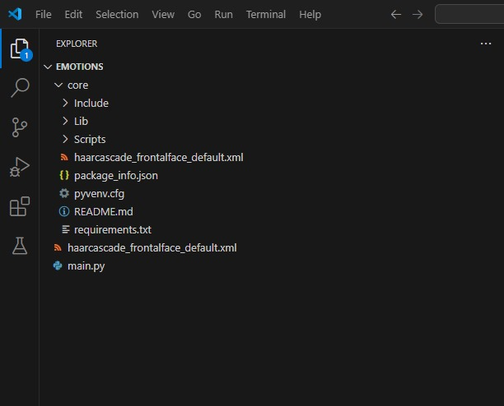

Figure 1final result after creating the virtual environment

We create the virtual environment from the Command Prompt, using the following commands :

1. On Cmd :

python -m venv myenv

1. Activate the Virtual Environment:

On Windows:

bash

myenv\Scripts\activate

1. On macOS/Linux:

Bash

source myenv/bin/activate

**2.Install Required Libraries :**

Use pip to install necessary libraries. For facial expression recognition, we need the following line of code :

pip install numpy

pip install opencv-python

pip install deepface

**3. Setup VS Code**

Open VS Code and navigate to your project folder.

Create a new file named main.py.

**4. Import Haar Cascade for Face Detection**

Download haarcascade_frontalface_default.xml from the OpenCV GitHub repository or use it from the OpenCV package if installed.

In main.py, import the necessary libraries and load the Haar Cascade classifier:

import cv2

from deepface import DeepFace

Load the pre-trained Haar Cascade model for face detection

face_cascade = cv2.CascadeClassifier(cv2.data.haarcascades + 'haarcascade_frontalface_default.xml')

**5.Run the Application :**

Execute your code in VS Code's terminal :

Python main.py

## 3.2 Development Algorithm and Code :

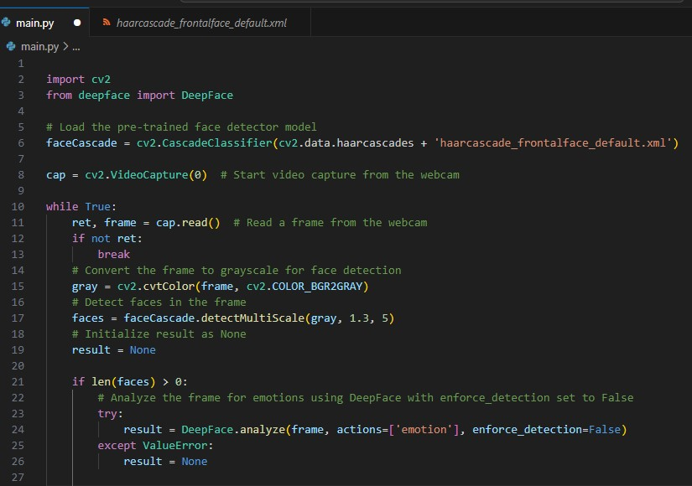

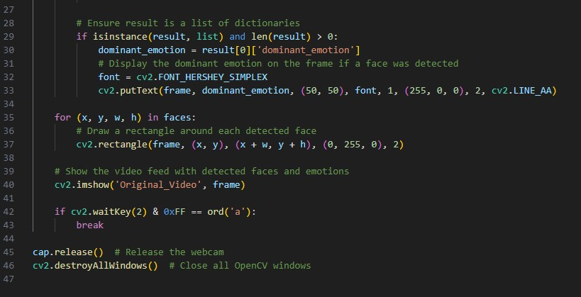

## 3.3 Output :

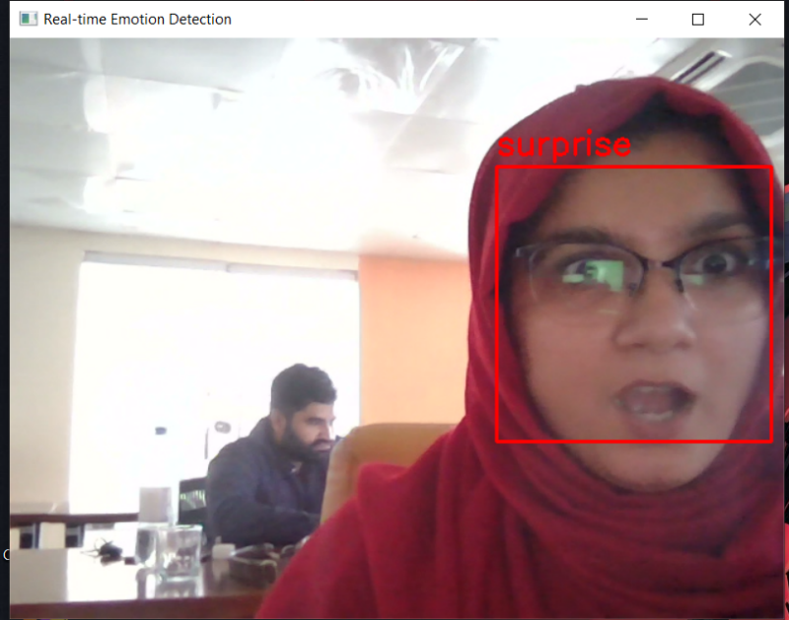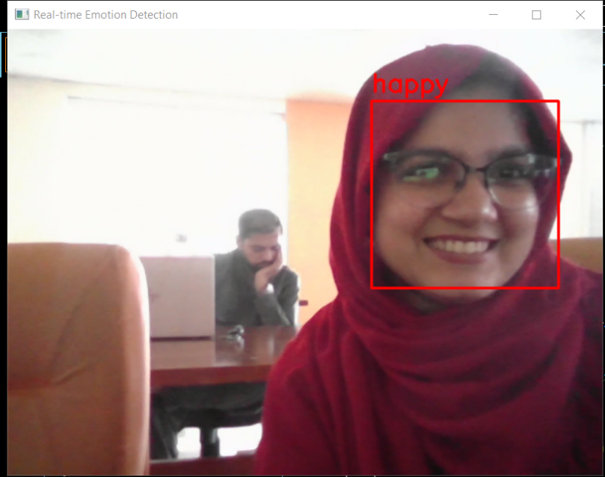

Figure 2Surprise_face

Figure1 _Happy face

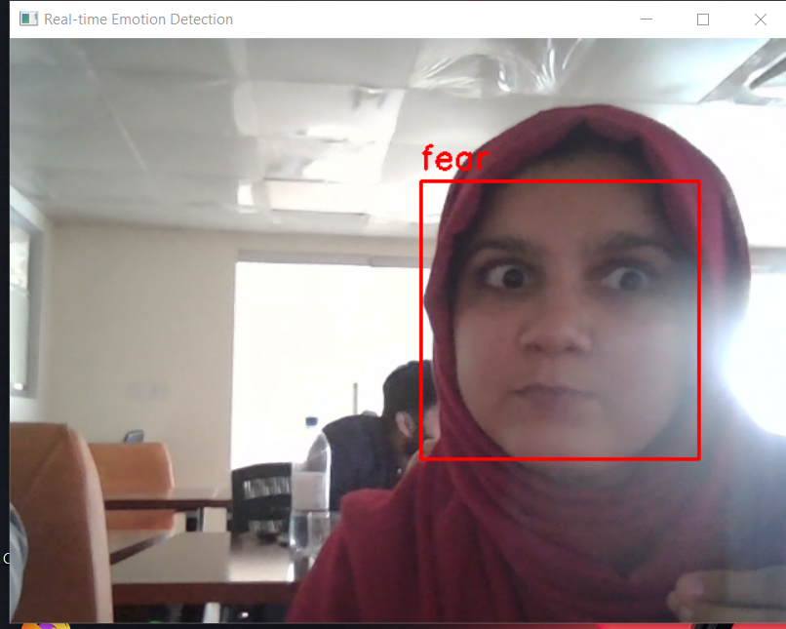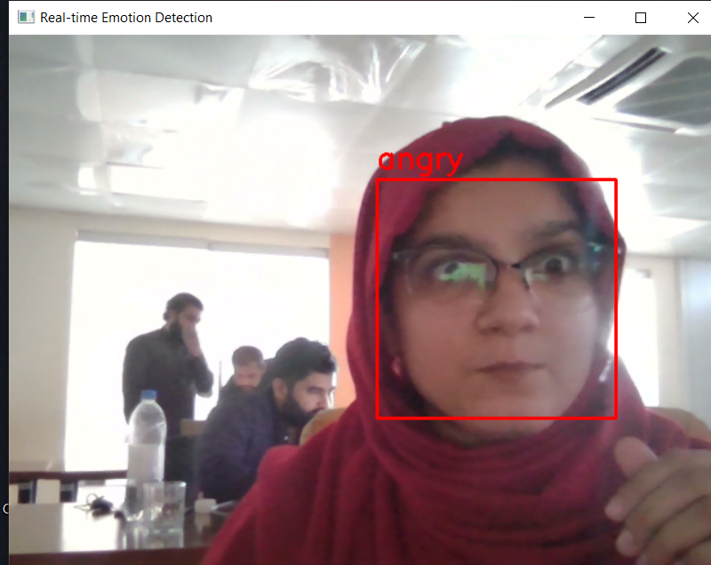

Figure 3Fear_face

Figure 4angry_face

## 3.4 Conclusion:

The facial expression recognition detector implemented in Python provides a robust solution for real-time emotion analysis. By leveraging OpenCV for face detection and DeepFace for emotion recognition, this code can effectively identify and display emotions such as anger, sadness, happiness, disgust, surprise, fear, and neutral. This technology has vast applications, from enhancing user experience in applications to aiding in psychological studies. As we continue to explore the intersection of technology and human emotion, tools like this will play a crucial role in bridging the gap between machines and human understanding.

## 3.5 Recommendations:

Use Deep Learning: Prefer deep learning models like CNNs for higher accuracy in emotion detection.

Data Augmentation: Enhance training data with varied lighting, angles, and expressions for robustness.